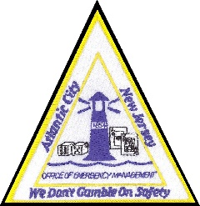
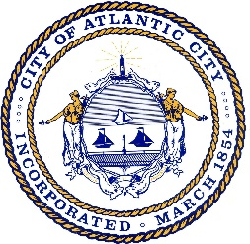
CITY OF ATLANTIC CITY
OFFICE OF EMERGENCY MANAGEMENT

2715 Atlantic Avenue ● Suite 420-A ● Atlantic City, NJ 08401
(609) 347-5466 Office ● (609) 347-5211 Fax ● (609) 347-5780 24 hour
TDD Number: (609) 347-5270
Edward Leon, LT, ACPD
Deputy EMC
eleon@acpolice.org

Michael Famularo, BC, ACFD
Deputy EMC
mfamularo@cityofatlanticcity.org

Scott Evans, chief, ACFD
Emergency Management Coordinator
evanss@cityofatlanticcity.org

For Immediate Release: April 19, 2020

The City of Atlantic City Office of Emergency Management was notified Sunday morning that a leak in a 30-inch main sewer line was discovered on the Bader Field site closest to Route 40/Albany Avenue. The sewer line services the Longport, Margate, and Ventnor communities, as well as the Chelsea Heights section of Atlantic City and Seaview Harbor Marina in Egg Harbor Township.

The Atlantic City Health Department and Atlantic City Office of Emergency Management are working with the Atlantic County Utilities Authority (ACUA) and the New Jersey Department of Environmental Protection to ensure the safety of the community and waterways.

Residents and businesses located in the affected areas are requested to conserve water to help alleviate and minimize the flow of water through the force main.

This area is utilized by recreational anglers. Atlantic City and the ACUA are actively working to notify local marinas, bait and tackle shops, and private dock owners.

ACUA contactors have responded and a plan has been developed to repair the leak. Arthur R. Henry Inc. Contractors and Engineers were on site today, and will begin the installation of a bypass system on Monday, April 20.

